- Which of the following is a scalar quantity?

  - Electric field strength
B. Work
C. Momentum
D. Velocity

- The power loss P in a resistor is calculated using the formula P = V²/R.
The uncertainty in the potential difference is 4 % and the uncertainty in the resistance is 3 %.
What is the uncertainty in P?

A. 11 % B. 13 % C. 9 % D. 5 %

3 A signal generator (a source of electrical oscillations) is connected to a cathode-
ray oscilloscope which has a screen 7.0 cm wide.

The diagram shows the waveform on the screen when the calibrated time-base is
set to 10 μs/cm.

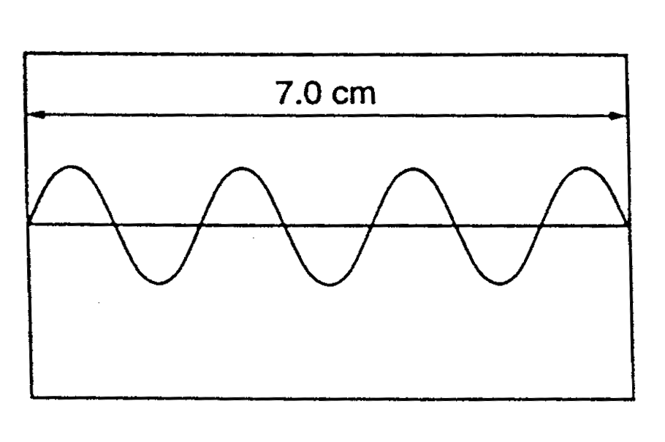
What is the period of the electrical oscillation?

A. 10 μs B. 20 μs C. 40 μs D. 100 μs

4. A parachutist steps from an aircraft, falls without air resistance for 2 s and then
opens her parachute.

Which graph best represents the variation with time t of her vertical acceleration
a during the first 5 s of her descent?
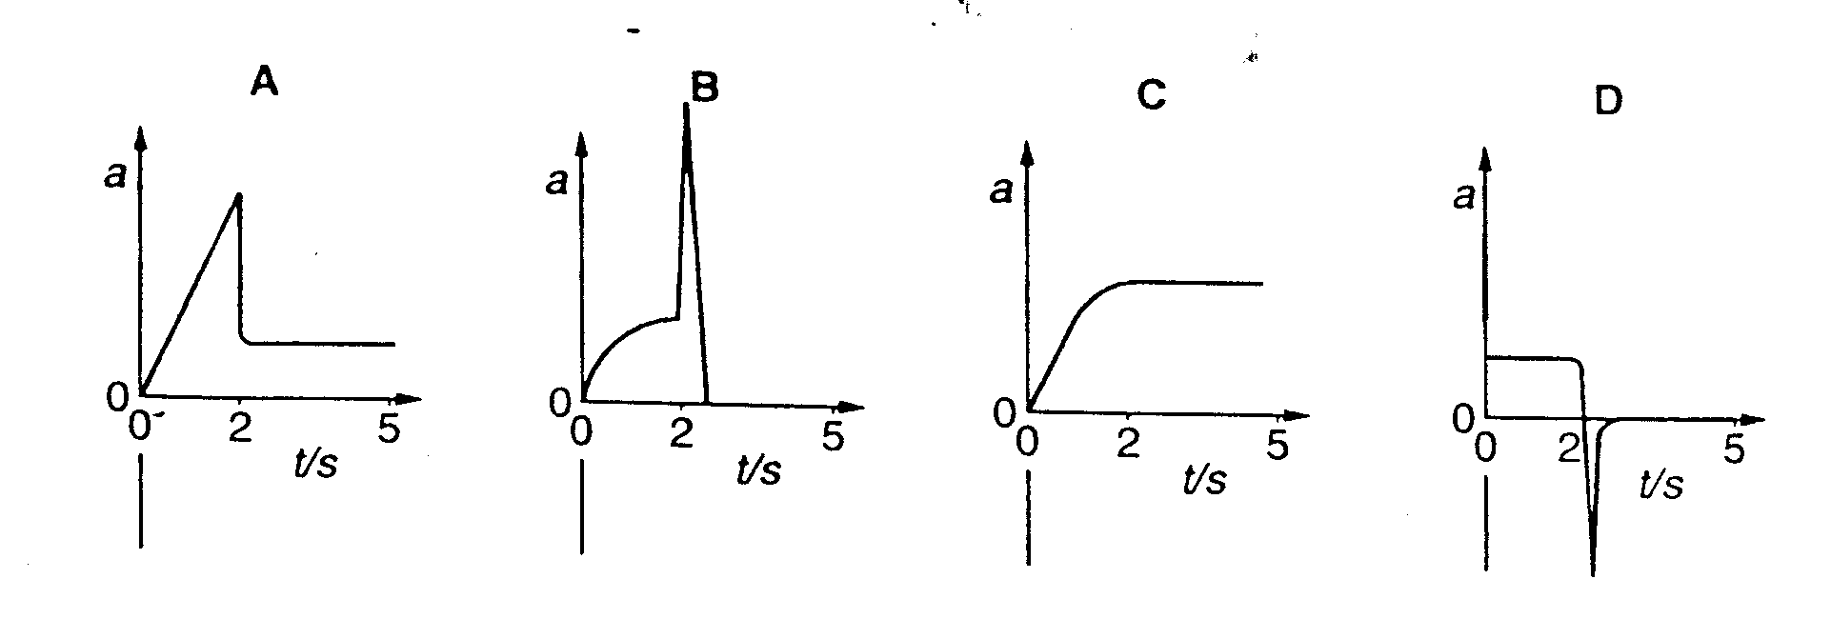

5. A quantity X is measured many times. A graph is plotted showing the number n
of times a particular value of X is obtained. X has a true value X₀

Which graph could be obtained if the measurement of X has a large systematic
error but a small random error?
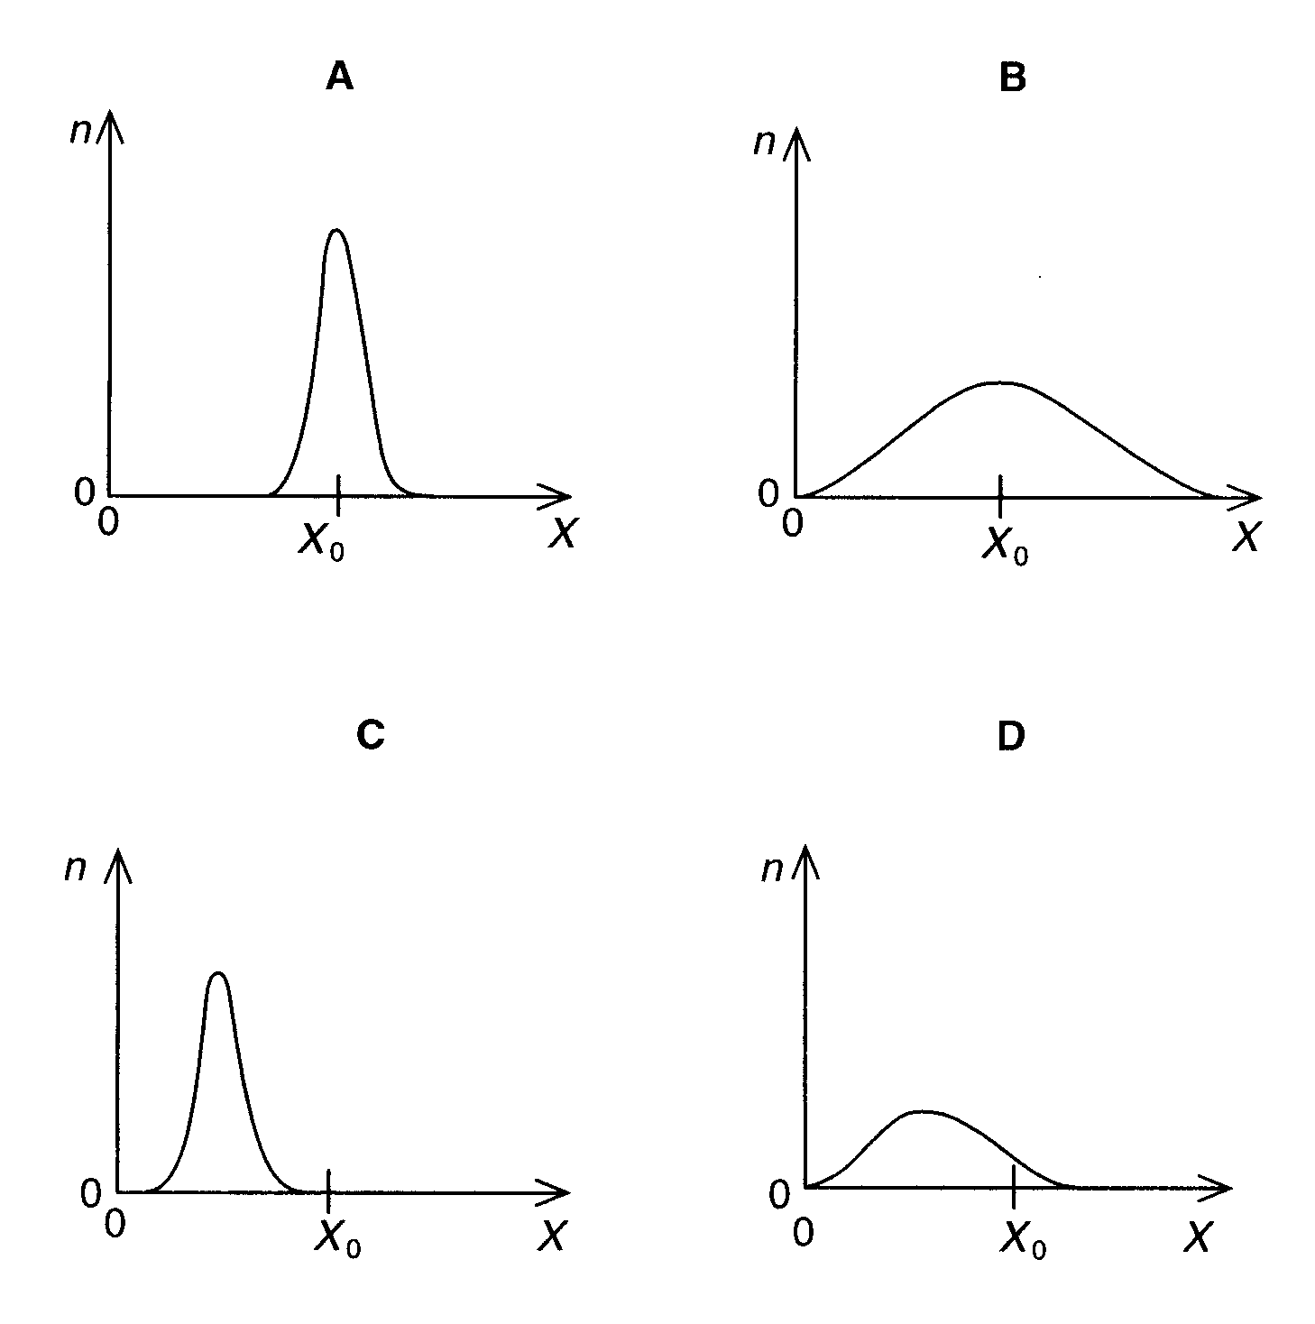
6. The graph relates to the motion of a falling body.

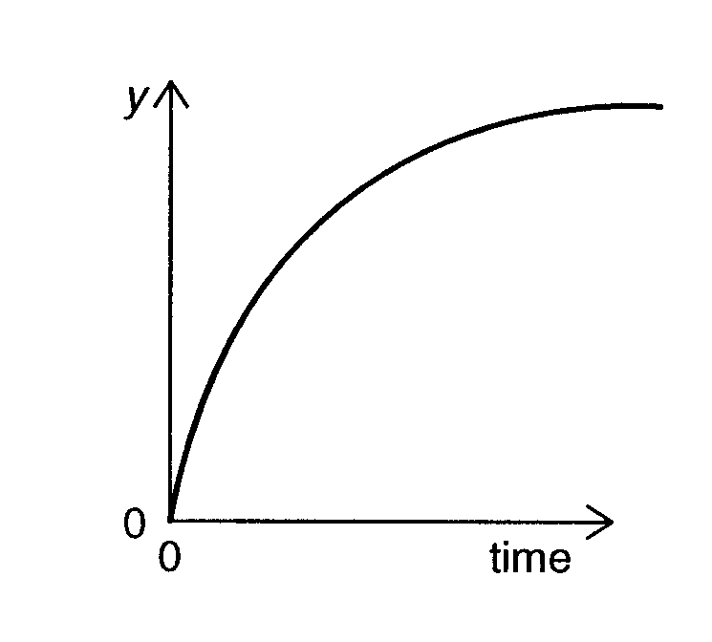

Which is a correct description of the graph?

A. y is the distance and air resistance is negligible

B. y is the distance and air resistance is not negligible

C. y is speed and air resistance is not negligible

D. y is speed and air resistance is negligible

7. A new design of car is described as being capable of braking from 24 ms⁻¹ to
rest in 6.0 s. The brakes provide a constant retarding force.

What is the distance the car travels when brought to rest from a speed of 24 ms⁻¹ ?

A. 72 m B. 78 m C. 152 m D. 40 m

8. A body of mass m travelling with speed 4u collides with and sticks to a body
of mass 4m traveling in the same direction with speed u.

4u u

4m
m

What is the speed with which the two travel after sticking together?

A. 2u/5 B. 4u/5 C. 6u/5 D. 8u/5

9. A box of mass 6.0 kg rests on a horizontal, rough surface. A string attached to
the box passes over a smooth pulley and supports a 2.0 kg mass at its other
end. 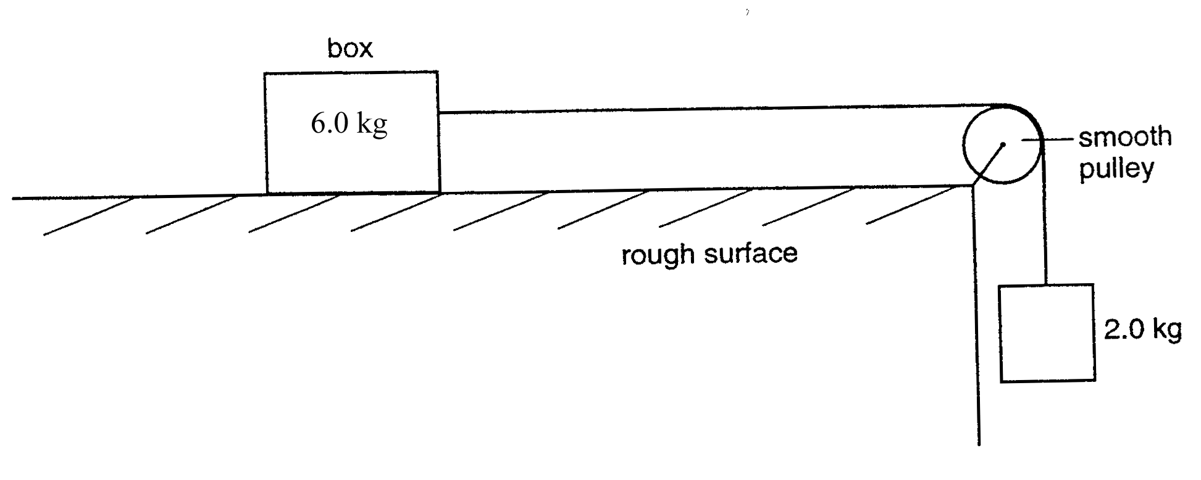
When the box is released, a friction force of 6.0 N acts on it.

What is the acceleration of the box?

A. 1.4 ms⁻² B. 1.7 ms⁻² C. 2.0 ms⁻² D. 2.5 ms⁻²

10. A heavy uniform plank of length L is supported by two forces F₁ and F₂ at
points distant L/4 and L/8 from its ends, as shown.

L

L/4 L/8

F₁ F₂

What is the value of F₁/F₂ ?

A. 2/5 B. 3/5 C. 2/3 D. 3/2

11. A child (mass m) sits on a car seat which is accelerating horizontally at 0.80 g
(where g is the acceleration of free fall).

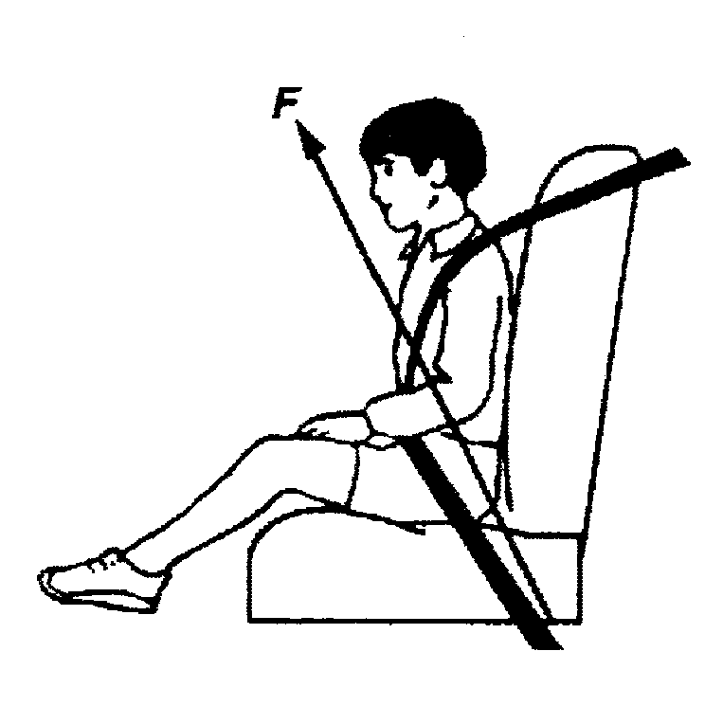

What is the magnitude of the total force F exerted by the car seat on the child?

A. 0.80 mg B. 1.0 mg C. 1.3 mg D. 1.8 mg

12. A ruler of length 0.50 m is pivoted at its center. Equal and opposite forces of
magnitude 4.0 N are applied to the ends of the ruler, creating a couple as
shown.
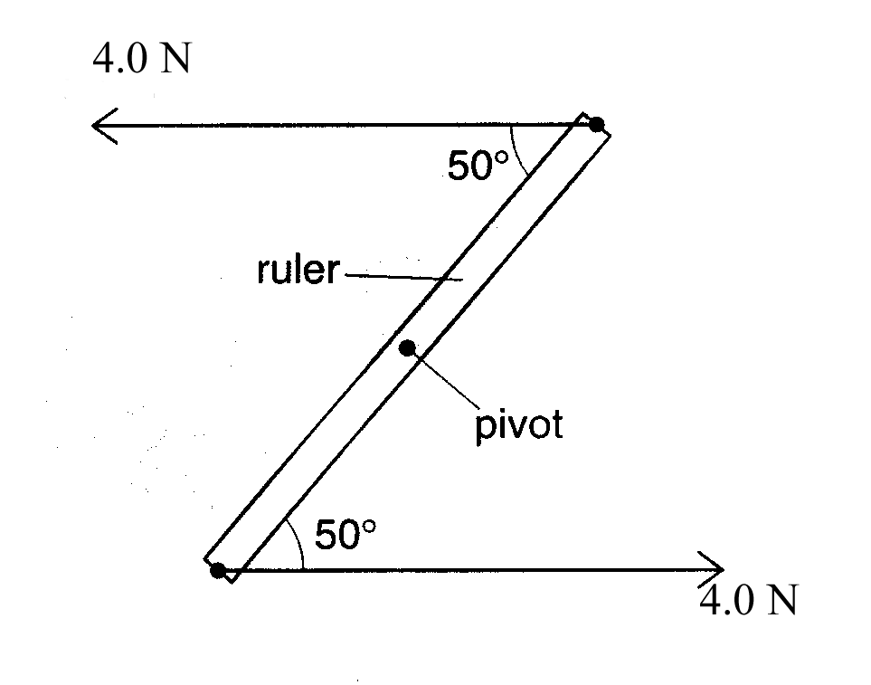

What is the magnitude of the torque of the couple on the ruler when it is in
the position shown?

A. 0.53 B. 1.53 C. 0.83 D. 1.93

13. A cylindrical block of wood has a cross-sectional area A and weight W. It is
totally immersed in water with its axis vertical. The block experiences
pressures P_{t} and P_{b} at its top and bottom surfaces respectively.

Which of the following expressions is equal to the upthrust of the block?

A. (P_{b} – P_{t}) A + W

B. (P_{b} – P_{t}) A

C. (P_{b} – P_{t}) A - W

D. (P_{b} – P_{t})

14. An object of mass m passes a point X with a velocity v and slides up a frictionless incline to stop at point Y which is at a height h above X.

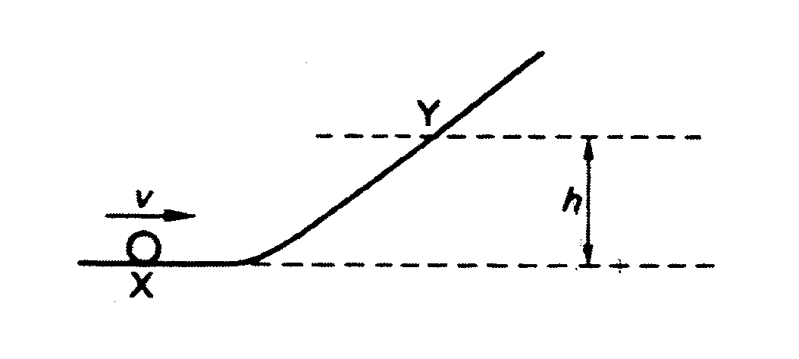

A second object of mass 2m passes X with a velocity of v/2. To what height will the second object rise?

A. h/2 B. h/4 C. h/8 D. h/16

15. A power station has an efficiency of 50 % and generates 1000 MW of
electrical power. What is the input power and the wasted power?

 | input power / MW | wasted power / MW
A | 2000 | 1000
B | 2500 | 1000
C | 2500 | 1500
D | 2000 | 1500

16. A constant pressure of 3.0 x 10⁴ Pa is exerted on a piston, of area 2.5 x 10⁻³ m²,
which encloses a gas as shown in the diagram.
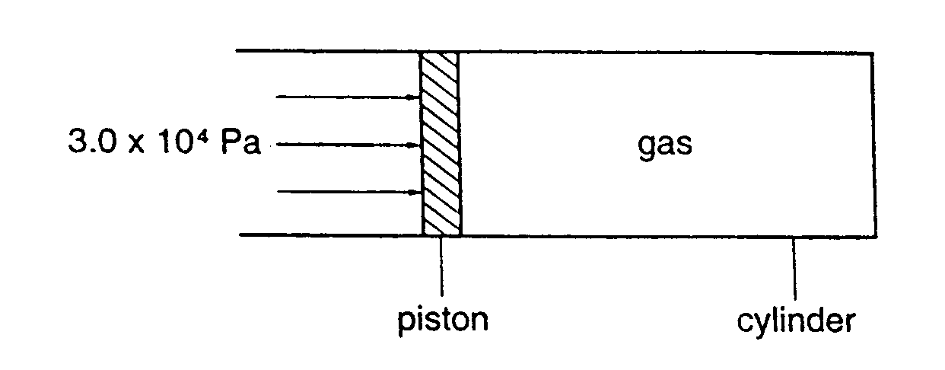
Friction between the piston and cylinder can be ignored

The gas is heated, the temperature rises and this causes the piston to move 4.0 mm.

How much work is done on or by the gas during this movement?

A. work done on the gas = 0.60 J

B. work done by the gas = 0.60 J

C. work done by the gas = 0.30 J

D. work done on the gas = 0.30 J

17. A steel wire of diameter d is found to have a strain of 1.0 x 10⁻⁴ when supporting a
certain load. This wire is replaced by a second wire of the same material and of the
same length but of diameter 0.5 d.

What is the strain when the second wire supports the same load, assuming that neither
wire exceeds its elastic limit?

A. 8.0 x 10⁻⁴ B. 4.0 x 10⁻⁴ C. 2.0 x 10⁻⁴ A. 5.0 x 10⁻⁵

18. Which line in the table gives approximate ratios of density and molecular spacing for
a substance in its solid, liquid and gas phases?

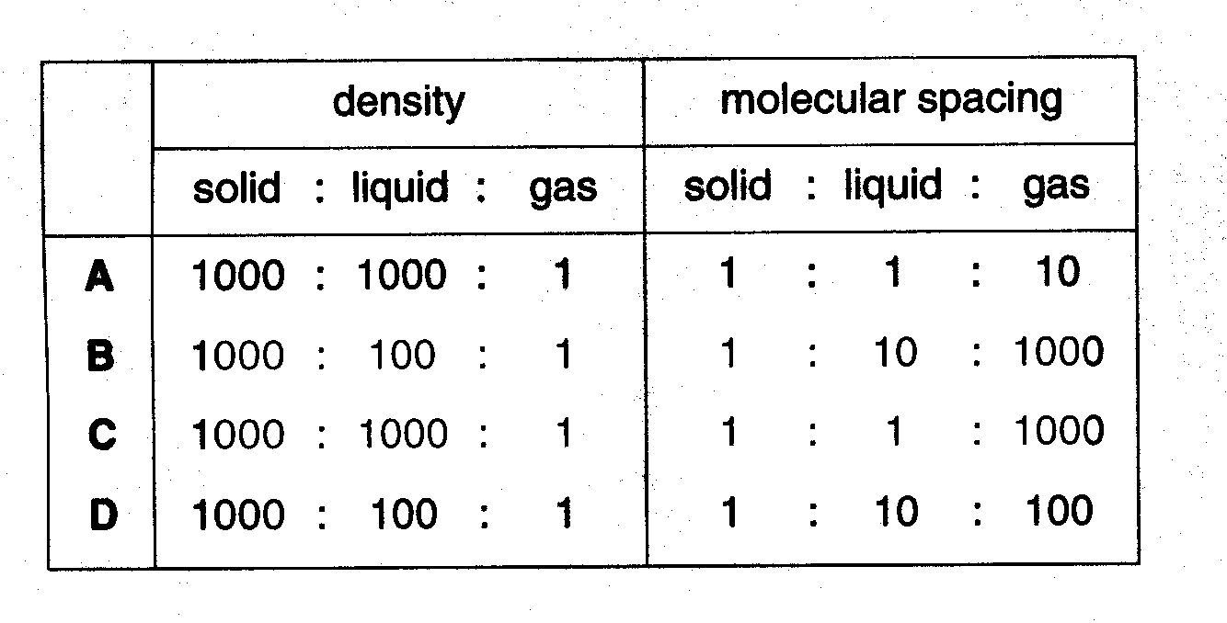

19. Two solid substances P and Q have atoms of mass m_{P} and m_{Q} respectively. They
have n_{P} and n_{Q} atoms per unit volume.

The density of P is smaller than the density of Q.

Which of the following must be correct?

A. m_{P} < m_{Q}

B. n_{P} < n_{Q}

C. m_{P}n_{P} < m_{Q}n_{Q}

D. m_{P}/n_{P} < m_{Q}/n_{Q}

20. The graph shows how the length l of a spring varies with the force F used to stretch
it.

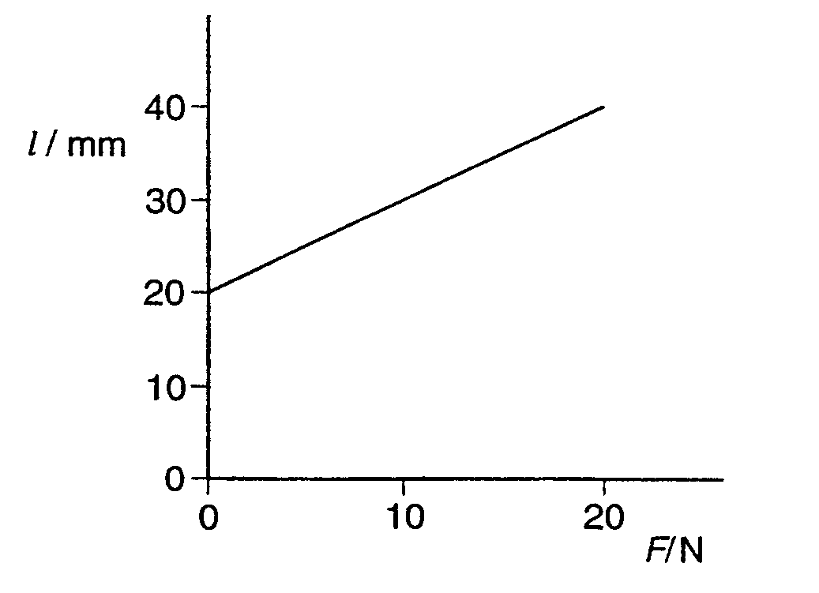

What is the strain energy of the spring when its length is 40 mm?

A. 0.8 J B. 0.6 J C. 0.4 J D. 0.2 J

21. A sound wave of amplitude 0.20 mm has an intensity of 3.0 W m⁻².
What will be the intensity of a sound wave of the same frequency which has an amplitude of 0.40 mm?

A 4.2 W m⁻² B 9.0 W m⁻²

C 6.0 W m⁻² D 12 W m⁻²

22. The figure below shows two identical loudspeaker driven in phase from a common audio – frequency source.
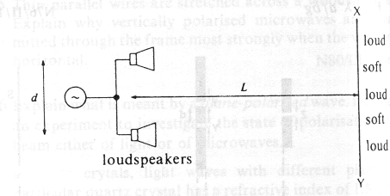
When a student moves from X to Y, the intensity of the note he hears is alternately loud and soft. Adjacent loud and soft regions may be made closer together by

A decreasing the amplitude
B decreasing distance d
C increasing distance L
D using a higher frequency

23. When a two – slit arrangement was set up to produce interference fringes on a screen using a monochromatic source of green light, the fringes were found to be too close together for convenient observation. In which of the following ways would it possible to increase the separation of the fringes?

A Decrease the distance between the screen and the slits
B Increase the distance between the source and the slits
C Have a larger distance between the two slits
D Replace the light source with a monochromatic source of red light

24. Fringes of separation y are observed in a plane 1.00 m from a Young’s slit arrangement illuminated by yellow light of wavelength 600 nm.
At what distance from the slits would fringes of the same separation y be observed when using blue light of wavelength 400 nm?

A 0.33 m B 0.67 m C 0.75 m D 1.50 m

25. Which one of the following summarises the change in wave characteristics on going from infra – red to X – rays in the electromagnetic spectrum?

 | Frequency | wavelength ( in a vacuum) | speed ( in a vacuum)
A | remains constant | decreases | decreases
B | decreases | increases | decreases
C | increases | increases | increases
D | increases | decreases | remains constant

26.

The figure above represents the propagation of a particle in a progressive wave traveling at a speed of 5.0 km s⁻¹.
What is the wavelength?
A 10 mm
B 15 mm
C 50 mm
D 100 mm

27. The principle of superposition states that

A the total displacement due to several waves is the sum of the displacements due to those waves acting individually.
B two stationary waves superimpose to give two progressive waves.
C a diffraction pattern consists of many interference patterns superimposed on one another.
D two progressive waves superimpose to give a stationary wave.

28. When monochromatic light of wavelength 5.0 x 10⁻⁷ m is incident normally on a plane diffraction grating, the second order diffraction line are formed at angles of 30º to the normal to the grating.
What is the number of lines per millimeter of the grating?

A 250 B 500 C 1000 D 2000

29. Which effect provides direct experimental evidence that light is a transverse, rather that a longitudinal, wave motion?

A Light can be diffracted.
B Two coherent light waves can be made to interfere.
C The intensity of light from a point source falls off inversely as the square of the distance from the source.
D Light can be polarized.

30. Why does the current increase when the potential difference applied across a metallic conductor is increased?

A There is less chance of a charge striking an atom.
B The mean time between collisions decreases.
C The acceleration of the charge carriers between collisions increases.
D The rise in temperature increases the thermal motion of the charge carriers.

31. A battery is connected in series with a 2 Ω resistor and a switch as shown in figure below. A voltmeter connected across the battery reads 12 V when the switch is open but 8 V when it is closed.

What is the internal resistance of the battery?

A  Ω B 1 Ω C  D 4 Ω

32. A rod is to be drawn from a 100 cm³ of metal of resistivity 1.76 10-⁸ Ωm. What is the cross sectional area of the rod if the resistance of the rod is to be 7 10⁻⁴ Ω?

A 2.5 10⁻⁹ m² B 4.7 × 10⁻⁹ m²

C 5.0 10⁻⁵ m² D 6.3 10⁻⁵ m²

33. A constant voltage d.c. source is connected, as shown in the diagram below, across two resistors of resistance 400 kΩ and 100 kΩ.

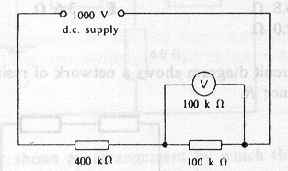

What is the reading of the voltmeter, also of resistance 100 kΩ, when connected across the second resistor as shown?

A 111 V B 125 V C 200 V D 250 V

34. Three similar light bulbs are connected to a constant – voltage d.c. supply as shown in figure below. Each bulb operates at normal brightness and the ammeter (of negligible resistance) registers a steady current.
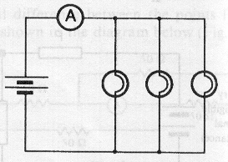

The filament of one of the bulbs breaks. What happens to the ammeters reading and to the brightness of the remaining bulbs?

 | ammeter reading | bulb brightness
A | increases | increases
B | increases | unchanged
C | unchanged | unchanged
D | decreases | unchanged

35. Three identical acid accumulators each having an e.m.f. of 2.0 V and a constant internal resistance of 1.0 Ω are connected in series with a 3.0 Ω resistor R, firstly in circuit ( i ), and secondly as in circuit ( ii).

What is the ratio of the power dissipated in R in circuit ( i ) to that in circuit ( ii )?

A 0.3 B 3.0 C 9.0 D 1.8

36. Three resistor are connected as shown in the circuit below with points A and B connected to a source of direct current.

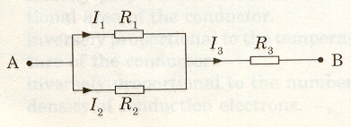
The ratio of 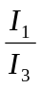 is

A 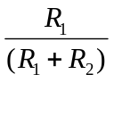 B 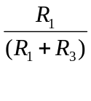

C 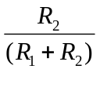 D 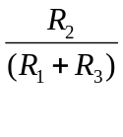

37. The nucleus of uranium (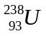) may undergo successive decays, emitting respectively an - particle, a  - particle and a - ray. The resulting nucleus may be represented by

A 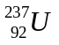 B 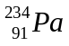

C 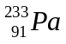 D 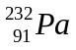

38. The isotope which decays by - emission to produce 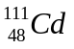 is

A 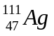 B 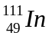

C 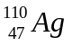 D 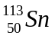

39. 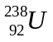 decays through a series of transformations to a final stable nuclide. The particles emitted in the successive transformations are

α β β α α

Which nuclide is not produced during this series of transformations?

A 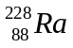 B 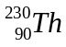

C D 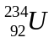

40. Which one of the following combinations of radioactive decay results in the formation of an isotope of the original nucleus?

A α and four β B α and two β

C α and β D two α and β

